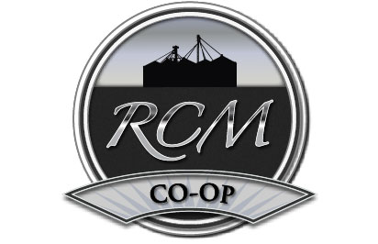

Culver: 217-636-7171 Plains: 217-626-1331 Mechanicsburg: 217-364-4438

STATEMENT OF GRAIN POLICIES FOR HARVEST 2025

STORAGE CHARGES ARE AS FOLLOWS:
CORN: 18 cents per bushel minimum through 11/30/2025; then 3.5 cents per bushel per month prorated daily through 08/31/2026.
BEANS: 21 cents per bushel minimum through 11/30/2025; then 4.0 cents per bushel per month prorated daily through 08/31/2026.
All grain stored after 8/31/2026 will be assessed additional minimum storage charges.

All bushels will remain on hold for no more than 7-Days from the date of delivery, after that period bushels will be placed in open storage.

DRYING & SHRINK POLICIES:
CORN: All corn sold at time of delivery will be shrunk to 15.0% moisture on a 1.4% shrink factor, with a drying charge of 2 cents per bushel per ½ point of moisture above 15.0%.
All stored corn will be shrunk to 14.5% moisture on a 1.4% shrink factor, with a drying charge of 2 cents per bushel per ½ point of moisture above 14.5%.

BEANS: Moisture discount is 1.25% shrink per bushel per ½ point of moisture from 13.1% to 15.0%; then 1.5% shrink per bushel per ½ point of moisture above 15.0%.

ALL DISCOUNTS ARE SUBJECT TO CHANGE WITHOUT NOTICE.

TRUCKING RATES: (Within 10 miles of our facility)

Corn: 13 cents per bushel

Beans: 14.5 cents per bushel

FARM-STORED COMMODITIES:
Please contact us and let us help you find the best markets for all of your farm-stored grain. We will evaluate all markets and find the best deal for you.

If you have any questions about our policies, please feel free to contact us at the offices listed above or visit us online at www.rcmcoop.com. Best wishes for a safe and bountiful harvest!

